Adrian McCovy Dental Professional
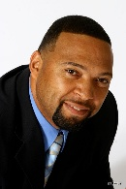
allen robinson robotics technology expert
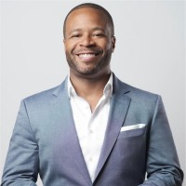
Allison Horn Vice President, Marketing
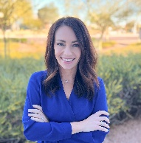
Arian B. Deutsch, CDT Certified Dental Technician
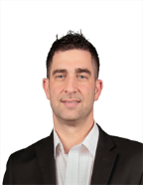
Brandon Dickerman Lab Equipment
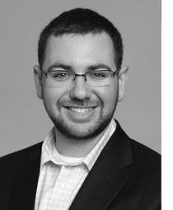
Brody Hildebrand DDS
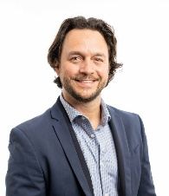

Catrise Austin Dental Professional
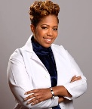
Charles Goodacre, DDS, MSD, FACP | Distinguished Professor
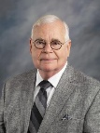
Christopher Brendemuhl DMD, Department Chair
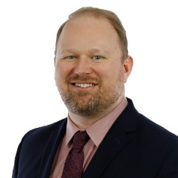
Cyrus Lee DMD, Executive Dental Director
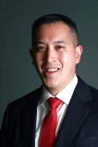
Darin Dichter, DMD Private Practice
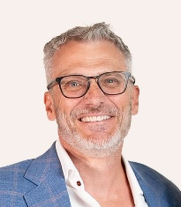
Douglas Benting, DDS, MS, FACP ACP President
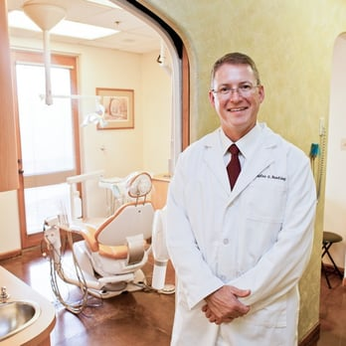
Dr. Algirdas Puisys DDS, PhD
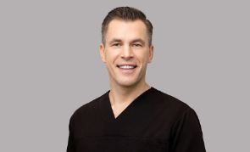
Dr. Allie Rascon Board-Certified Periodontist & Implant Specialist
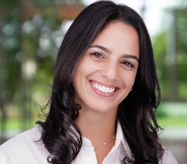
Dr. Alonso Carrasco-Labra DDS, MSc, PhD
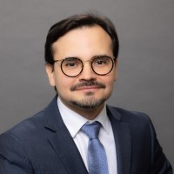
Dr. Andy Burton Dental Specialist
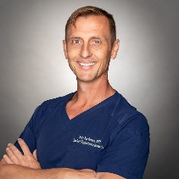
Dr. Angel Garcia-CaÃ±as Contemporary Implant Dentistry Specialist
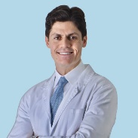
Dr. Anthony Sallustio DDS
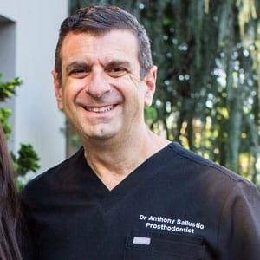
Dr. Arndt Guentsch DMD, PhD, MHBA, MS
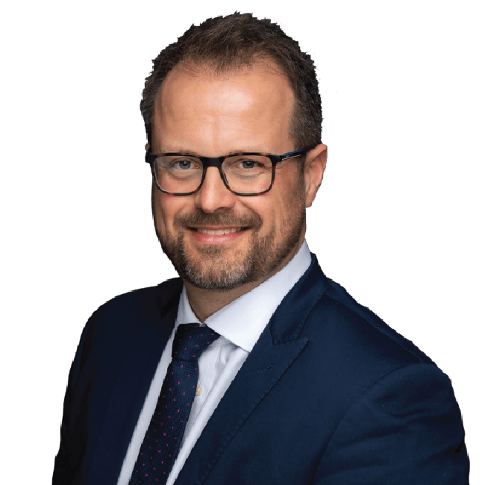

Dr. Athena Goodarzi Key Opinion Leader Straumann Group - Full-Arch Specialist
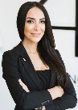
Dr. Azam Saeed International Speaker - Straumann Digital Excellence Center
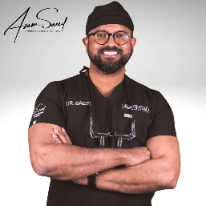
Dr. Ben Kellum DDS, Full Arch Specialist
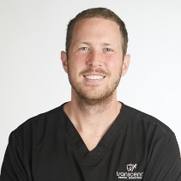
Dr. Benjamin Pliska Sleep Medicine
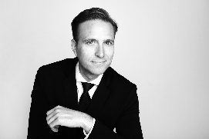
Dr. Bradley Ross DMD
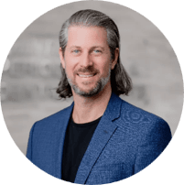
Dr. Brent Barta Owner & CEO, West 10th Dental Group
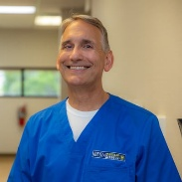

Dr. Brian J. Jackson DDS, DABOI/ID, Honored Fellow AAID
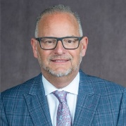\
Dr. Bruce G. Freund DDS
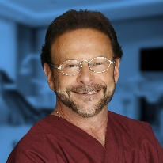
Dr. Carlos de Carvalho Prosthodontist
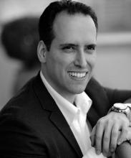
Dr. Christian Coachman CDT, DDS
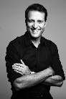
Dr. Christian Hart DDS, Full Arch Specialist
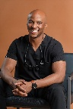
Dr. Clark Damon CEO Texas Implant Institute - Nobel Biocare Lecturer
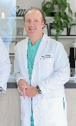

Dr. Craig I. Aronson DDS, FAGD, FAAID, DABOI/ID
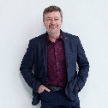
Dr. Craig M. Misch Complication Prevention
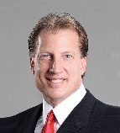
Dr. Dan Holtzclaw Extramaxillary Implants
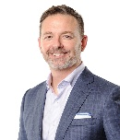
Dr. Daniel Domingue DDS, DABOI/ID, DICOI
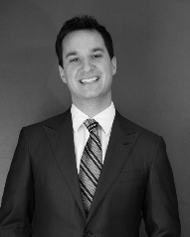
Dr. David A. Fenton Emergency Management
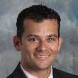
Dr. David L. Cochran DDS, PhD
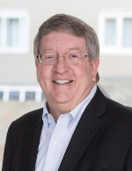
Dr. David Resnick DDS, FAAID, DABOI/ID
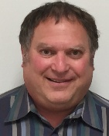

Dr. DeVonte Johnson DMD, Dentist and Owner, Eastside Dental Group
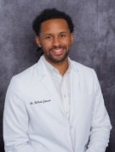
Dr. Dean Morton Prosthodontist
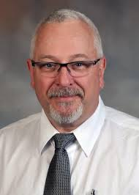
Dr. Dimitris N. Tatakis DDS, PhD
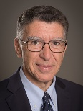
Dr. Donald J. Provenzale DDS, DABOI/ID, AFAAID
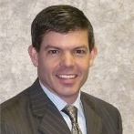
Dr. Drew Phillips Valedictorian & Multi-State Implant Educator
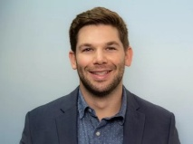
Dr. Duke Heller DDS, MS, Honored Fellow AAID
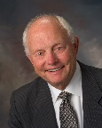
Dr. Ed R. Kusek DDS, FAAID, DABOI/ID, Past President AAID
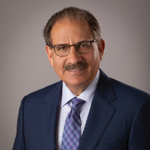

Dr. Fadi Hasan DDS, MSD
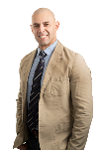
Dr. Frank Caputo DDS, AAID Diplomate
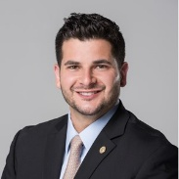
Dr. Frank M. Spear DDS, MSD
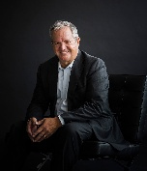
Dr. Galip Gurel DDS, MSc
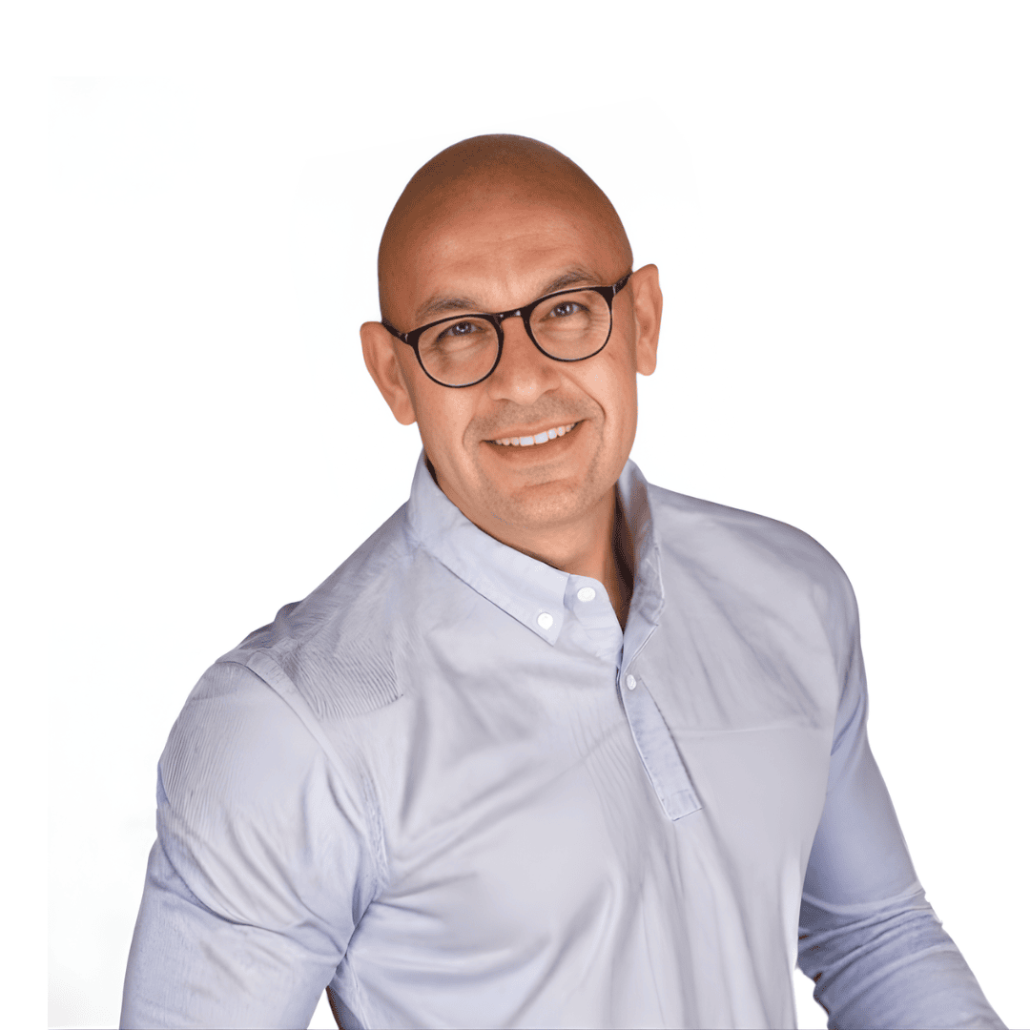
Dr. George Arvanitis DDS, DABOI, Honored Fellow AAID
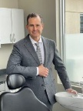
Dr. George Tysowsky Dental Technology Economist
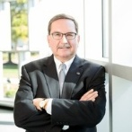
Dr. Gerard J. Chiche DDS
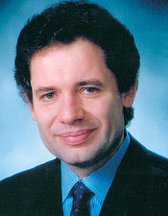

Dr. Giorgio Tabanella DDS, MS
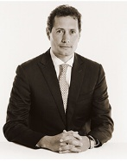
Dr. Gustavo Giordani DDS
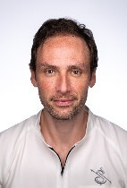
Dr. Hesham Nouh DSc, Clinical Professor
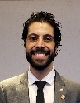
Dr. Howard Gluckman BDS, MChD, PhD
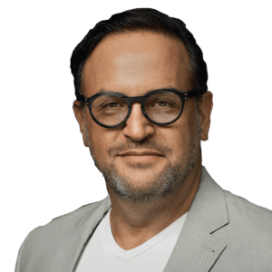
Dr. Hussam Batal DMD, Clinical Professor
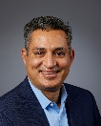
Dr. Ihab Hanna DDS, FAAID-DABOI, DICOI
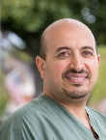
Dr. Isabella Rocchietta DDS, MSc
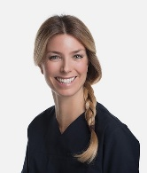

Dr. Istvan Urban DMD, MD, PhD
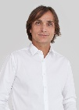
Dr. JB White DDS, AAID Member
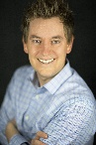
Dr. Jaideep R. Deshpande MBA, Executive Director, Strategy and Marketing
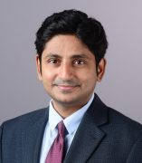
Dr. James Fetsch Fellow Academy of General Dentistry - Implant Specialist
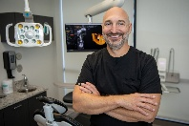
Dr. James Nager DMD, Associate Fellow AAID
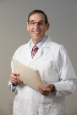
Dr. Janice Wang DDS, ABOI/ID Diplomate, AAID Fellow
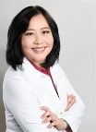
Dr. Jason Kim DDS, AAID Fellow, ABOI/ID Diplomate
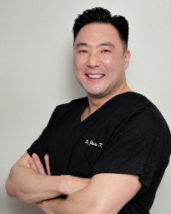

Dr. Jeff Briney Comprehensive Dentistry & Laser Specialist
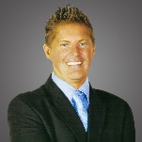
Dr. Jim Janakievski DDS, MSD
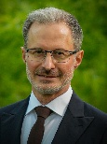
Dr. John Minichetti DMD, DABOI/ID, Fellow AAID
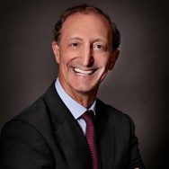
Dr. John Sorensen Prosthodontist
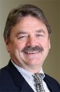
Dr. Jonathan Tsang DMD, DABOI/ID
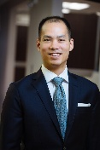
Dr. Joseph Leonetti DMD, DABOI/ID, FAAID
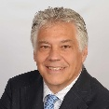
Dr. Junji Tagami DDS, PhD
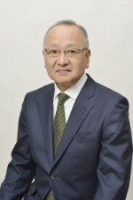

Dr. Kathryn Alderman Chief Executive Officer, Intelligent Care Alliance; Director, AI and Technology Integration, Dental AI Association
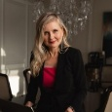
Dr. Keith Long Implant Specialist
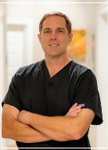
Dr. Kwan M. Lee DDS, DABOI, DICOI
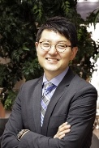
Dr. Laura Williams Professor
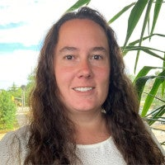
Dr. Lily Hu DMD, Board-Certified Anesthesiologist
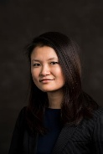
Dr. Loren Israelsen DDS, Founder and CEO
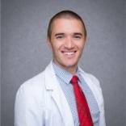
Dr. Louis K. Rafetto Office-Based Anesthesia
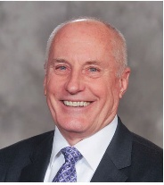

Dr. Marco Veneziani DDS
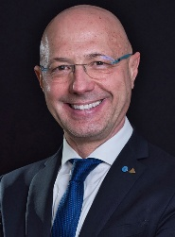
Dr. Markus Hurzeler DDS, PhD
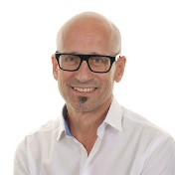
Dr. Marta Revilla Leon Prosthodontist
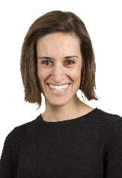
Dr. Martin Mendelson Professional Development
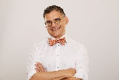
Dr. Matthew Fay Sleep Medicine Specialist
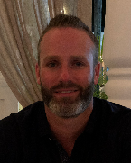
Dr. Matthew Fien DDS
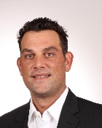
Dr. Michael A. Pikos Full-Arch Therapy
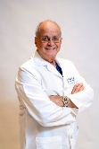
Dr. Michael Cohen Periodontal & Implant Specialist - Founder of Seattle Study Club
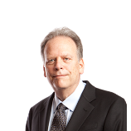
Dr. Michael D. Scherer Full-Arch Implantology
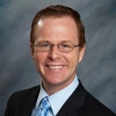
Dr. Michael R. Andersen Prosthodontist & Maxillofacial Prosthetist
